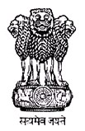

Requirement of photograph for passport.

Based upon the specifications of the International Standards Organization (ISO) and ICAO, which is responsible for standardizing travel documents, the most important requirements for a photograph for e-passport is that the face must be taken from a full frontal position and the height of the face must meet the prescribed specifications. The eyes must be open, level and clearly visible within the indicated area. The face should be centred within the frame.

Advice for Passport Applicants to Submit Proper Quality Photograph

The quality of the photograph appearing on the passport depends on the photograph that is submitted at the time of applying for a passport. The passport seekers are, therefore, advised to submit the photographs, as specified, to avoid delay in processing their passport applications.

Sample Photo

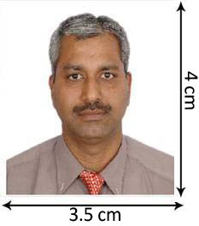
- The photograph should be in colour and of the size of 3.5cm x 4 cm

- The photo-print should be clear and with a continuous-tone quality.
- It should have full face, front view, eyes open.
- Photo should present full head from top of hair to bottom of chin.
- Center head within frame.
- The background should be a plain white or off-white.
- There should not be any distracting shadows on the face or on the background.
- Head coverings are not permitted except for religious reasons, but the facial fea tures from bottom of chin to top of forehead and both edges of the face must be clearly shown.
- The expression on the face should look natural.

Do’s and Dont’s for a Proper photo

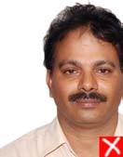
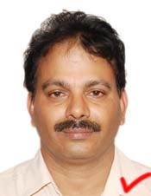
The photo should capture full face, front view, with eyes open. The head should be in the centre of the frame.
Distracting
background.
Not centered

There should be no distracting shadows on the face or

background.
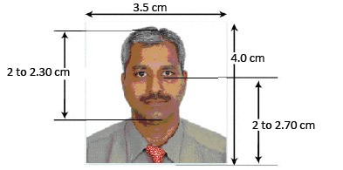
Make sure photo presents full head from top of hair
to bottom of chin;

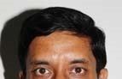
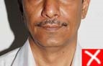
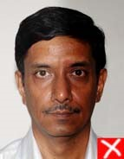
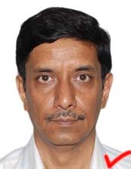
Lighting on face and background The light should be even and balanced to avoid shadows on the face.
Shadows
behind head.

Shadow
across the
face.

Background behind the face should be properly illuminated to avoid shadows in the background.

Photograph Print Properties
The photograph should be in size 3.5 x 4.0 cm and in colour.
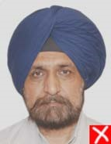
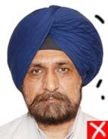
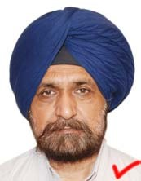
Blurred

Ink marked/
creased
Print photo on thin photo paper or stock.

Ensure the print is clear and has a continuous-tone quality.
Do not retouch or otherwise enhance or soften the photo.

Resolution and Printing Quality
High-resolution photography and printing are strongly recommended.

Both conventional and digital photography are acceptable, and conventional or digital printing methods may be used.
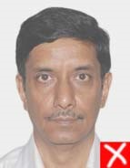
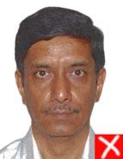
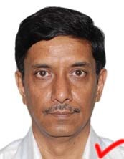

Washed out
colours

Pixelated
Resulting print should exhibit a continuous-tone quality regardless of the print method used (dye sublimation, ink jet, laser, etc.)

Digitally printed photos should be
produced without visible pixels or dot patterns

Fine facial features should be discernible.

Contrast and Colour
Brightness and contrast should be adjusted to present the subject and background accurately.

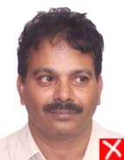
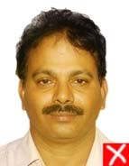
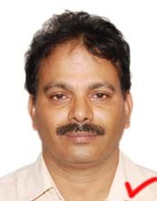
Photos without proper contrast or colour may obscure unique facial features. Colour should reproduce natural skin tones.
Looking
away

Unnatural
skin tones

Fluorescent or other lighting with
unbalanced colour may cause unwanted colour cast in the photo. Appropriate filters can eliminate improper colour balance.

Head & Eyes- Position and Background
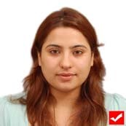
Head should face the camera directly and should not tilt or turned (portrait style).

Hairs across

Eyes closed

Photo must show both edges of the face clearly.

The eyes must be open, level eyes and clearly visible and must not be covered by hairs or eyeglass farmes.

Eyeglasses
Glare on eyeglasses should be avoided with a slight upward or downward tilt of the head. No tinted or dark glasses.
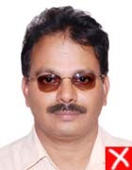
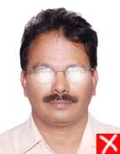
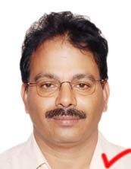
reflection on

Dark tinted
lenses

Flash
lenses.
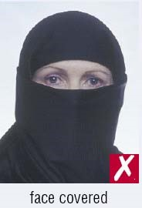
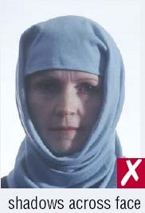
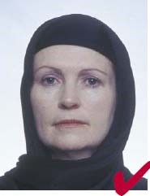
Head coverings are not permitted except for religious reasons, but the facial features from bottom of chin to top of forehead and both edges of the face must be clearly shown.

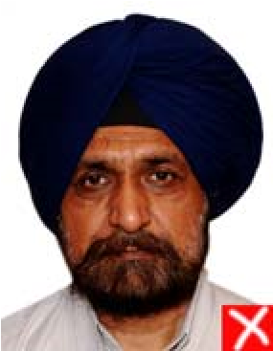
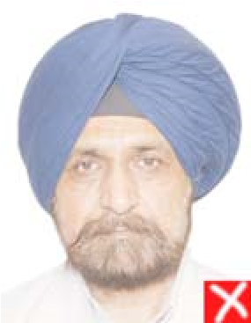
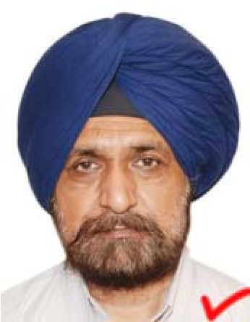
Exposure and Lighting There should not be any overexposure or under-exposure which results in an unusable photo.

Too dark.

Too light.

There should be a three-point
balanced lighting. Facial features should be clearly evident in the photo.

Lighting should be adjusted to avoid shadows on the face or background. Diffuse sources of light, such as umbrella lights, are preferable to point sources.

Flexibility in Childrens' photographs
Babies under one year do not have to have their eyes open.

As regards the photograph of the children under ten years of age, requirements can be somewhat relaxed in respect of height of the face, and the position of the eyes in the photographs; and in case of babies and infants also, the position of the face, the facial expression, the eyes and
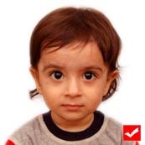
the line of sight can have some Shows Mouth open

relaxation. However, a frontal background and toy close to face photograph with clarity is required for children. It should show the child alone (no chair backs, toys or other people visible), looking at the camera with a neutral expression and the mouth closed.

Photographs taken with a digital camera should be of high quality colour.

